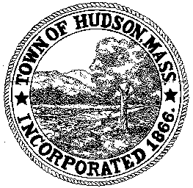

BOARD OF HEALTH
78 Main Street
Hudson, MA 01749
(978) 562-2020
Meeting Agenda
March 6, 2012
7:00 PM

- Preliminaries
1.1 Open Meeting
1.2 Roll Call

2.0 General Business
2.1 Update on 2nd Annual Hudson Cook-off

2.2 Substance Abuse Discussion

2.2 Minutes February 14, 2011

3.0 New Business

4.0 Old Business

5.0 Correspondence

6.0 Adjournment

Next Meeting March 20, 2012

